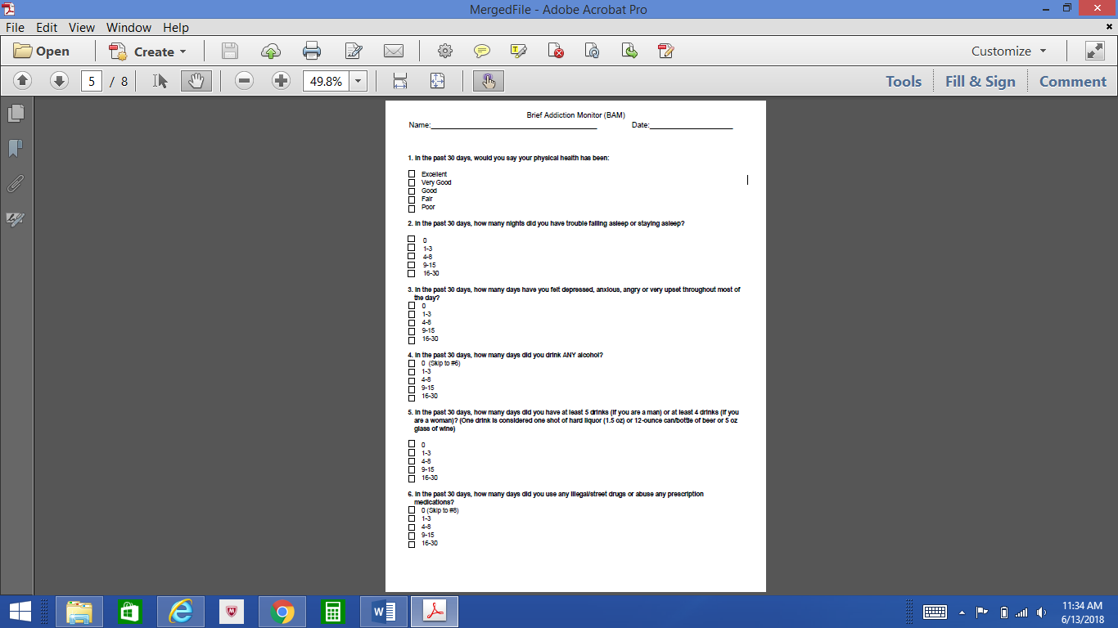
About the BAM
Brief Addiction Monitor (BAM)

What does it measure?
The Brief Addiction Monitor (BAM) is a multidimensional scale of addiction used during Substance Use Disorder (SUD) treatment, which includes symptom level and functional outcomes. It is a brief, 17-item instrument administered either as a clinical interview or by patient self-report and can typically be completed in about 5 minutes. The initial administration of the BAM provides a retrospective assessment (past 30 days) of three SUD domains: risk factors for substance use, sobriety-related protective factors, and actual patient reported drug and alcohol use. Subsequent administrations of the BAM cover anywhere from the past 7 days to as long as 30 days. A unique feature of the BAM is that it focuses on both patient strengths and problem areas. Areas of strengths noted by the BAM include religious or spiritual beliefs, work pursuits, financial status, participation in treatment, and social supports for recovery. Problem areas identified by the BAM may include interpersonal difficulties, risky behaviors, sleep problems, and emotional and/or physical health problems.

Alternative Forms
There are three additional forms of the BAM measure. The BAM-R is a continuous response BAM that allows responders to give the actual number of days rather than intervals of days (e.g., 4-8, 9-15 days) when answering questions. The BAM-IOP (Intensive Outpatient) is intended to be administered on a weekly basis, as it asks patients to respond according to the last seven days. The BAM-C (Consumption) assesses only items relating to self-reported substance use over the past 30 days.

Availability
The BAM was developed by the United States Department of Veterans Affairs (VA) to assess patient outcomes in SUD specialty treatment. It is available in the public domain and can be accessed through the VA MIRECC website: https://www.mirecc.va.gov/cih-visn2/Documents/Clinical/BAM_with_Info_Sheet.pdf. The BAM is widely used in VA Medical Centers and in military settings. It was chosen for inclusion in the VA’s measurement-based care initiative and is one of the measures in the Behavior Health Data Portal (BHDP), a software platform used to measure and examine patient-level clinical outcomes in military behavioral health clinics.

Scoring the BAM

What is the scoring range?
Each item on the BAM is rated on a Likert scale from 0-4. There is currently no validated total summary score. However, there are three sub-scales called “factors”. The Use factor score (sum of items 4, 5, & 6) ranges from 0-12, while the Risk factor (sum of items 1, 2, 3, 8, 11, & 15) and Protective factor (sum of items 9, 10, 12, 13, 14, & 16) scores each range from 0-24. Item 17 can be examined as an overall indicator of treatment progress.

During treatment, the goal is to maximize the Protective factor score to Risk factor score ratio as a sign of initiating and maintaining abstinence from substance use.

What are the clinical cutoffs?
There are no reported total clinical cutoff scores for the BAM, so it is best used to establish an individual’s baseline and for monitoring changes over the course of treatment. Information obtained is used clinically to evaluate treatment response and inform treatment interventions. Further examination and attention of the BAM subscales are necessary clinically under the following conditions: a score of 1 or greater on any item in the Use subscale; a total score of 12 or
greater on the Risk subscale; or a score of 12 or below total on the Protection subscale. It is always important to discuss the results with patients to inform them of their progress, build motivation for treatment, and engage in collaborative treatment planning. When changes are not evident, providers and patients should make necessary adjustments to the treatment plan together.

How should a provider interpret results?
As with any assessment, the clinical context and purpose for administering the measure should be considered when interpreting results. When using the BAM, providers are strongly encouraged to attend to the item-level data (in addition to the three factor scores) because single items have direct implications for treatment planning. That is, they identify specific areas of need or resources patients brings to bear in their recovery.

Using the BAM in Practice

How should providers use the results in treatment planning?
The BAM is a measure that can be used in screening, ongoing evaluation of treatment progress, and final treatment outcome. By examining individual items, providers can identify strengths to build upon or concerns to address through the treatment planning process. A general rule is that if the Protective subscale score is greater than the Risk subscale score, the patient is at less risk for use. Conversely, if the Risk score is greater than the Protective score, then a patient is at increased risk for use. If these scores are equal, the patient is at risk of use and the focus of treatment should be on building protective factors and coping with risk factors. A helpful approach while treatment planning is to elicit the patient’s reactions to the BAM results, and collaboratively develop a problem list and specific interventions to address these issues.

References
Cacciola, J. S., Alterman, A. I., DePhilippis, D., Drapkin, M. L., Valadez, C., Fala, N. C.,…& McKay, J. R. (2012). Development and initial evaluation of the Brief Addiction Monitor (BAM). The Journal of Substance Abuse Treatment, 44(3), 256–263. doi:10.1016/j.jsat.2012.07.013.
Center of Excellence in Substance Abuse Treatment and Education (CESATE). (2010). Treatment planning with Brief Addiction Monitor (BAM). Retrieved from https://vaww.portal.va.gov/sites/OMHS/SUD/Lists/BAM/AllItems.aspx.
Department of Veterans Affairs. (2014). Introduction to the Brief Addiction Monitor (BAM): A tool to support measurement-based care for people with substance use disorders. Retrieved from https://www.mentalhealth.va.gov/communityproviders/docs/BAM_Overview_01-28-2014.pdf
Department of Veterans Affairs. (n.d.). BAM Assessment Resources: Developed by the VISN 4 MIRECC. Retrieved April 26, 2022 from https://www.mirecc.va.gov/cih-visn2/Documents/Clinical/BAM_with_Info_Sheet.pdf
DePhilippis, D., Goodman, J., Beamer, K., & Bloedorn, S. (2014). Brief Addiction Monitor (BAM) manual for use in SUD group treatment. Retrieved from https://vaww.portal.va.gov/sites/OMHS/SUD/Lists/BAM/AllItems.aspx.
Gaddy, M. A., Casner, H. J., & Rosinski, J. (2018). Factor structure and measurement invariance of the Brief Addiction Monitor. The Journal of Substance Abuse Treatment, 90, 29-37. doi:10.1016/j.jsat.2018.04.010.
Nelson, K. G., Young, K., & Chapman, H. (2014). Examining the performance of the Brief Addiction Monitor. The Journal of Substance Abuse Treatment, 46, 472-481. doi:10.1016/j.jsat.2013.07.002.

