Patient Health Questionnaire (PHQ)

About the PHQ

What does it measure?
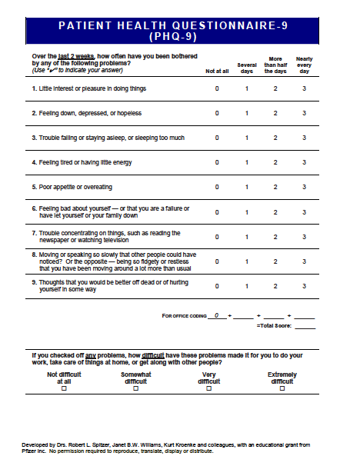
The Patient Health Questionnaire (PHQ) is a self-report instrument that measures depression severity. The PHQ-9 is a nine-item measure that incorporates characteristic symptoms of Major Depressive Disorder and the presence and duration of suicidal ideation. Alternative forms of the PHQ depression measure include the PHQ-2. The PHQ-2 is a brief measure of depression that comprises the first two questions of the PHQ-9. Primary care settings typically use the PHQ-2 to briefly screen patients for depression. It is recommended to administer the full PHQ-9 after a patient endorses the first two items on the PHQ-2.

Availability
All PHQ measures are available in the public domain. No permission is required to reproduce, translate, display or distribute them. The PHQ measures were developed by Drs. Robert L. Spitzer, Janet B.W. Williams, Kurt Kroenke and colleagues with the support of an educational grant from Pfizer Inc. The PHQ-2 and PHQ-9 are also included in the battery of measures available within the Behavior Health Data Portal (BHDP). The BHDP is a software platform used to measure and examine patient-level clinical outcomes in military behavioral health clinics.

Scoring the PHQ
What is the scoring range?
Each item is rated on a four-point scale from 0, indicating the least severity, to 3, indicating the greatest severity. The overall range for the PHQ-9 is 0-27 for the total score. The PHQ-2 is used as a brief screener with an overall range of 0-6.

What are the clinical cutoffs, if any?
Scores of 5, 10, 15, and 20 represent cut points for mild, moderate, moderately severe, and severe depression, respectively on the PHQ-9. The PHQ-8 is scored like the PHQ-9, with identical cut points. For the PHQ-2, a score of 3 is used as a clinical cutoff score, indicating the need for additional assessment.

How should a provider interpret results for the PHQ-9?

Score | Depression Severity | Proposed Treatment Actions
0 – 4 | None-Minimal | None
5 – 9 | Mild | Watchful waiting; repeat PHQ-9 at follow-up
10 – 14 | Moderate | Treatment plan, considering counseling, follow-up and/or pharmacotherapy
15 – 19 | Moderately Severe | Active treatment with pharmacotherapy and/or psychotherapy
20 – 27 | Severe | Immediate initiation of pharmacotherapy and, if severe impairment or poor response to therapy, expedited referral to a behavioral health specialist for psychotherapy and/or collaborative management

Using the PHQ in Practice

How should providers use the results in treatment planning?
Although the PHQ-2 is an excellent screening measure, it is not intended to be used as an outcome measure. Providers should use the PHQ-9 as an objective measure of depression severity. The PHQ-9 can be used to establish a baseline of depression severity and to guide the provider in the type and intensity of therapeutic intervention. The PHQ-9 may be utilized to assess changes over time in depressive symptomology and responses to treatment. As a tool for measurement-based care, the PHQ-9 can assist with validating the patient’s experience, empowering decision-making, and positively impacting the clinical relationship.

Note: Copies of the PHQ family of measures, including the GAD-7, are available at www.phqscreeners.com.
The website requests acknowledgement of use agreement and that, “Content found at the PHQ Screeners site is expressly exempted from Pfizer’s general copyright restrictions; content found on the PHQ Screeners site is free for download and use as stated within the PHQ Screeners site.” (phqscreeners.com)

References
Kroenke K., & Spitzer R. L. (2002). The PHQ-9: A new depression diagnostic and severity measure. Psychiatric Annals, 32, 509-521.
Kroenke, K., Spitzer, R. L., & Williams, J. B. W. (2001). The PHQ-9: Validity of a brief depression severity measure. Journal of General Internal Medicine, 16(9), 606-613. doi: 10.1046/j.1525-1497.2001.016009606.x.
U.S. Department of Veteran Affairs, Department of Defense. (2022). VA/DoD clinical practice guideline for the management of major depressive disorder. Retrieved from https://www.healthquality.va.gov/guidelines/MH/mdd/VADoDMDDCPGProviderSummaryFinal508.pdf

